A Project Report On

**“Game Stop”**

Submitted To

**Savitribai Phule Pune University**

In partial fulfilment of the degree of

**Bachelor of Business Administration - Computer Application**



By

**Shreyas Khandagle 14426**

BBA-CA

**(Semester IV)**

Under the guidance of

**Mrs. Padma Nene**

Research Guide

MES Garware College of Commerce, Karve Road, Pune 411004 (2021-2022)

MES GARWARE COLLEGE OF COMMERCE, PUNE-411004.

BACHELOR’S OF BUSINESS ADMINISTRATION – COMPUTER APPLICATION

**CERTIFICATE**

This is to certify that,  **Mr. Shreyas Khandagale**, Roll Number: **14426.** University Exam Seat Number: ------ . Student of BBA-CA Semester-IV has successfully completed the project work in specialization subject **HTML, CSS, JS** entitled as **Game Stop** a partial fulfillment of the degree of Bachelors of Business Administration Computer Application as per the syllabus of Savitribai Phule Pune University Year 2020-2021.

I further clarify that, the work has been carried out under my supervision.

Project Guide BBA-CA Coordinator Officiating Principal

Internal Examiner External Examiner

**ACKNOWLEDGEMENT**

We would like to express our special thanks of gratitude to our teacher,

Mrs. Padma Nene, for her valuable time, guidance, support, and the

golden opportunity to do this project. We came to know about many new things while working on this project.

Shreyas Khandagale,

BBA-CA

**SYNOPSIS**

|  |  |
| --- | --- |
| **Topic / Project Title** | **Game Stop [ Informative Gaming Website]** |
| **Name Of Group Members** | **Shreyas Khandagale (14426)** |
| **Technology** | * **Html** * **CSS** * **Javascript** |
| **Objective / Aim** | * **An informative website with**   **all the games, news,**  **tournaments and videos every**  **gamer needs.**   * **A website which will take user**   **information and allow them to**  **play tournaments.** |

**CONTENT**

1. Introduction
2. System Design
3. Snaps of Pages
4. Software & Hardware Requirement
5. Future Scope
6. Conclusion
7. Biblography and References.

**Introduction**

* The purpose of this study was to develop a gaming information website which will help gamers find their favourite games easily through our website. Till now gamers had to go from website to website for genuine news but now they can get all the news from our website.
* With the help of our website the users can also register for various tournaments that they want to play and they can also watch the tournaments.
* GameStop provides Play option(if the game is free)which will direct the gamers to the game's respected websites, and Purchase option…

(*if the game is paid*).

**System Design**

ERD -

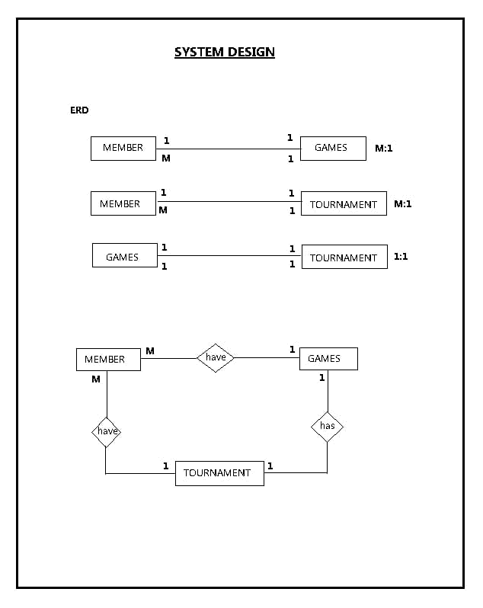

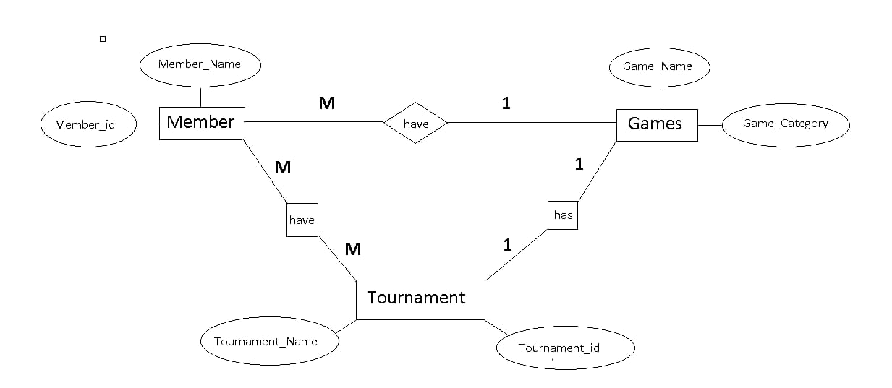

DFD -

**Context Level**

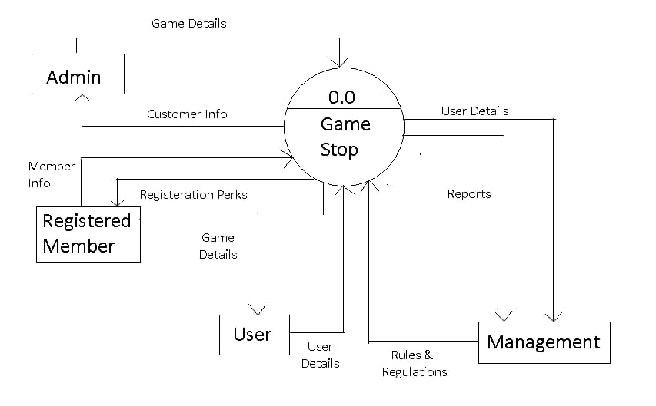

Master Maintainence

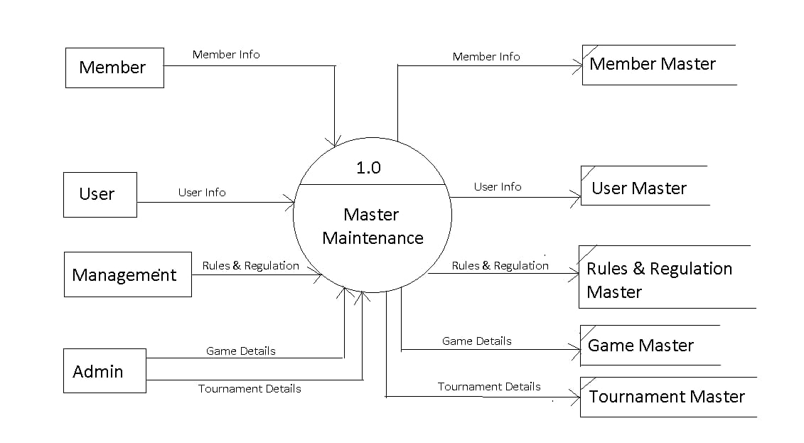

2nd Level

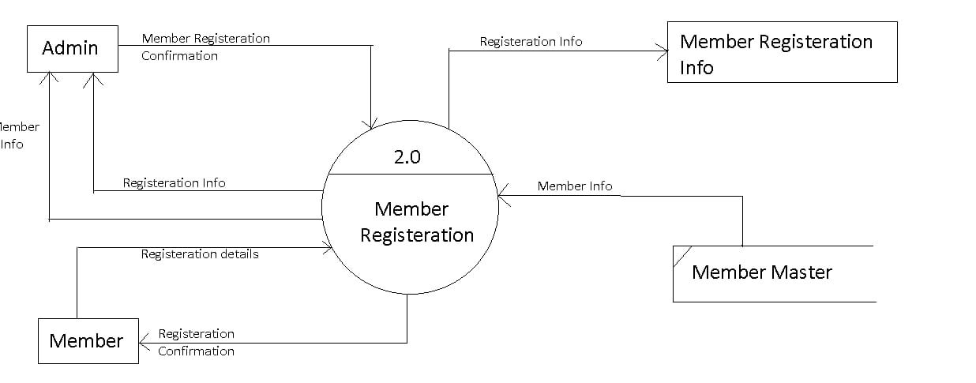

3rd Level

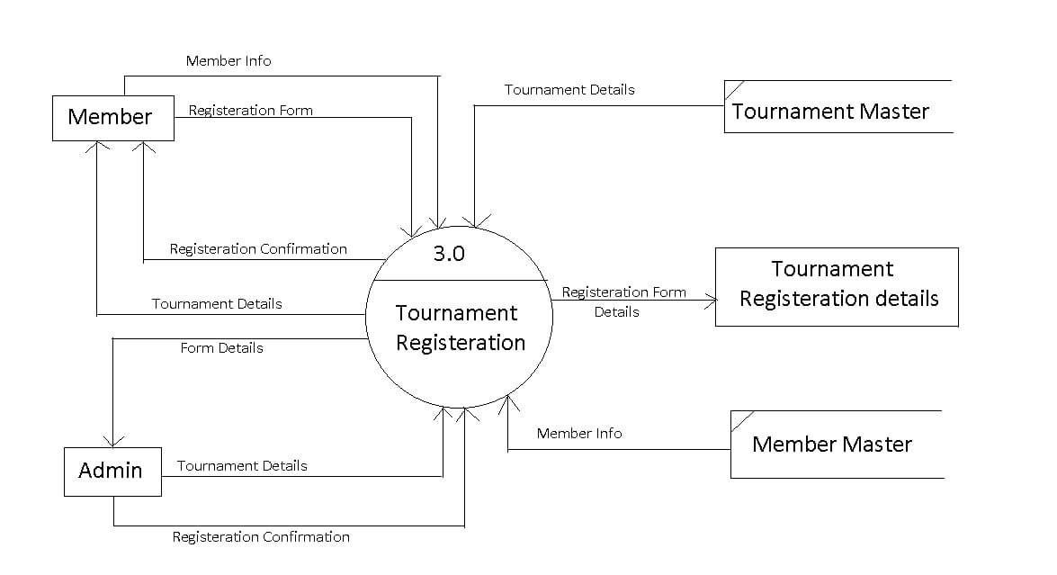

4th level

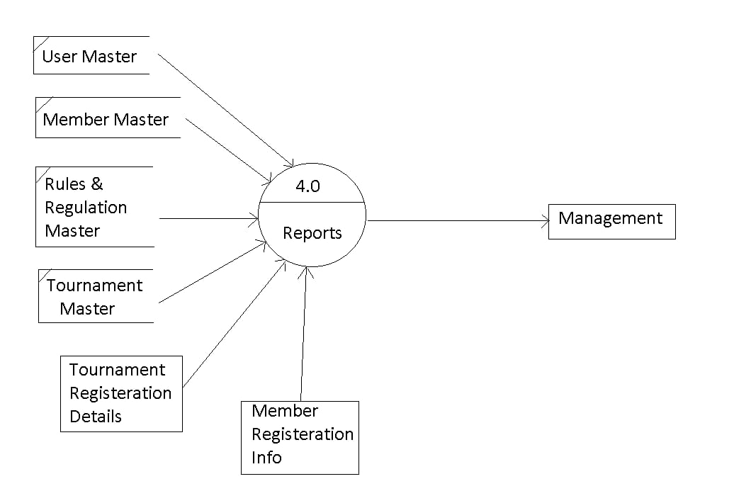

**Snaps of Pages**

*Home Page-*

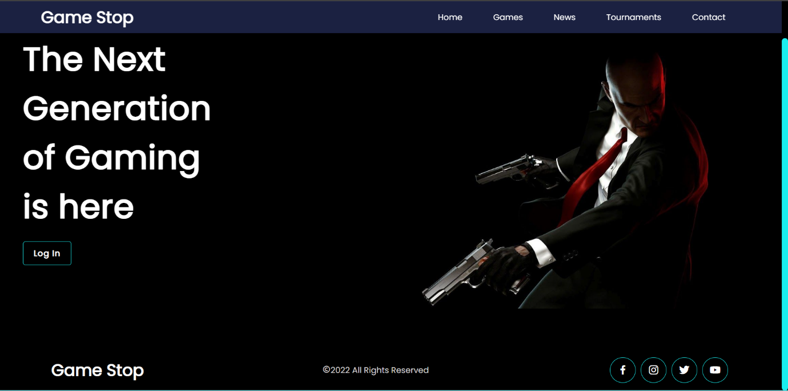

*Login-*

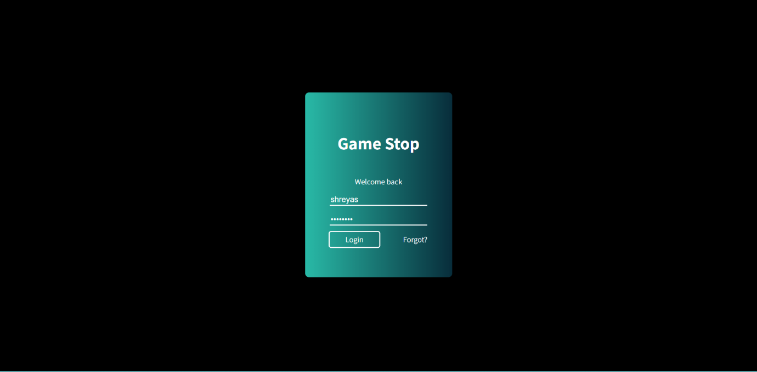



*Games Section-*

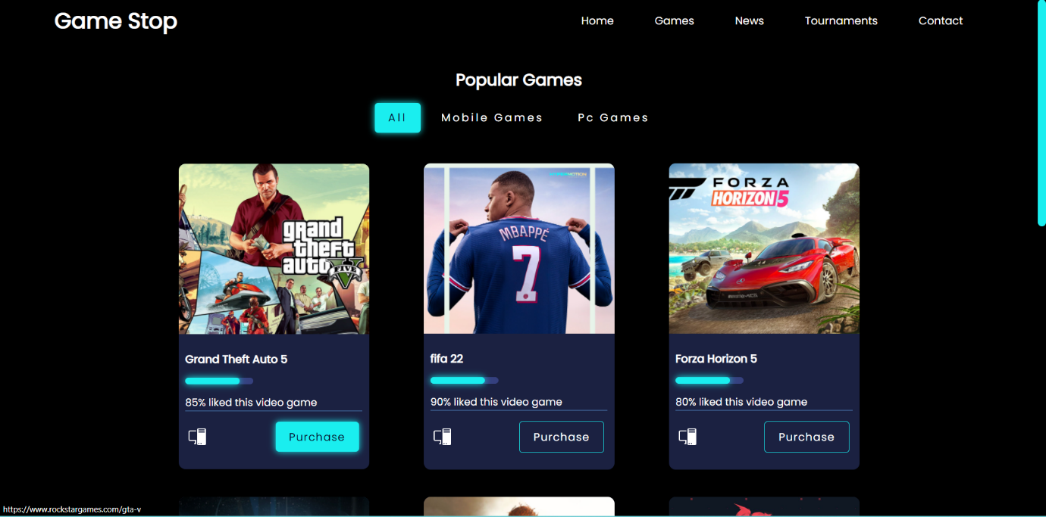



*Filtered Games-*

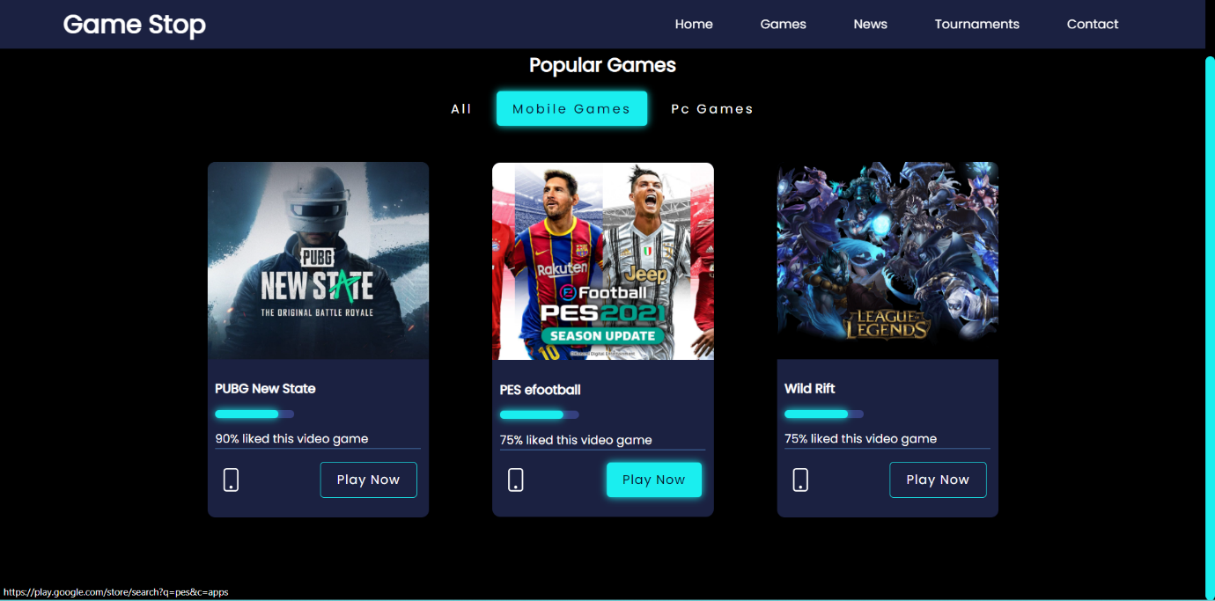

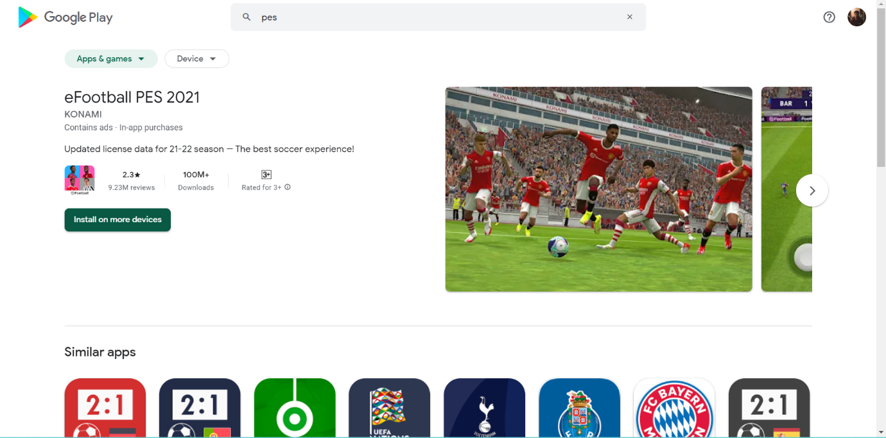

*News Section-*





*Tournament Section-*

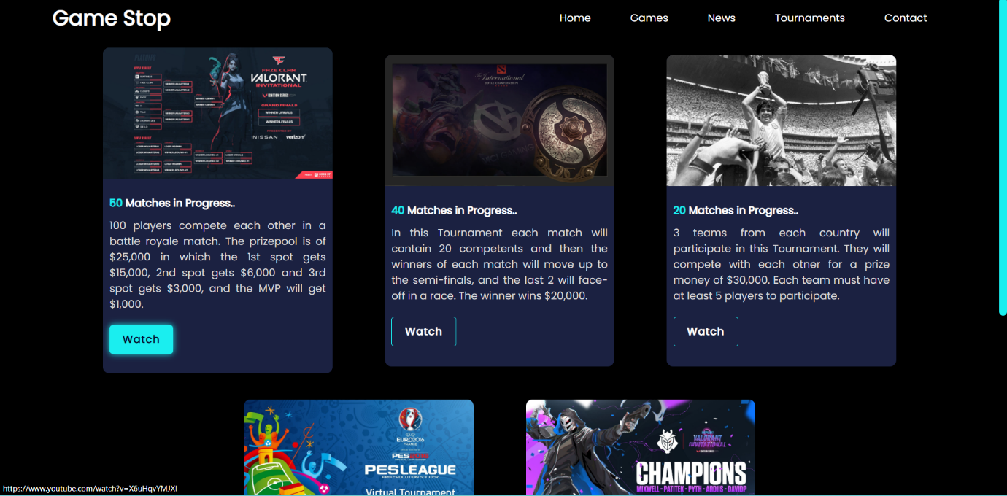

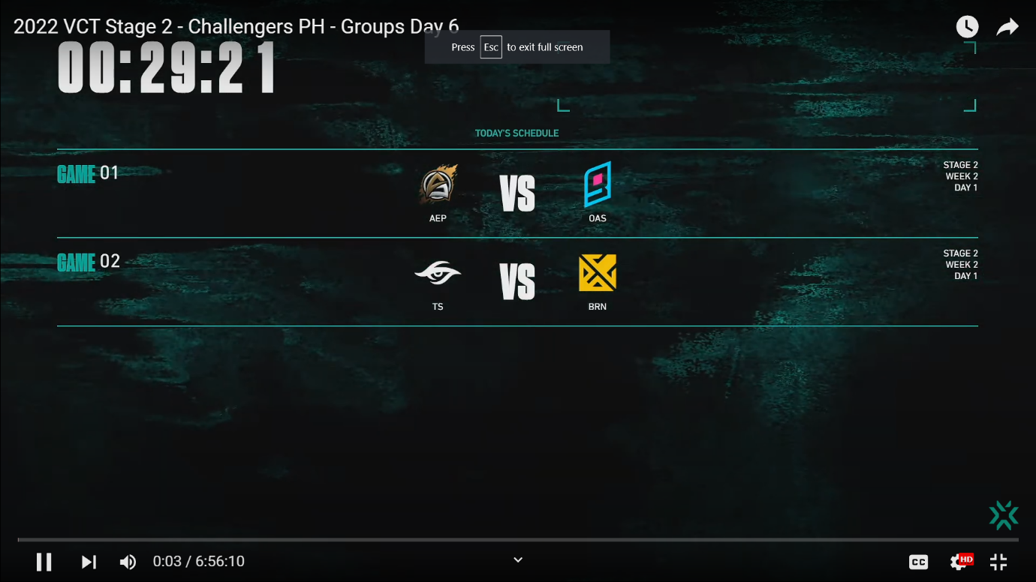

*Contact and Feedback-*

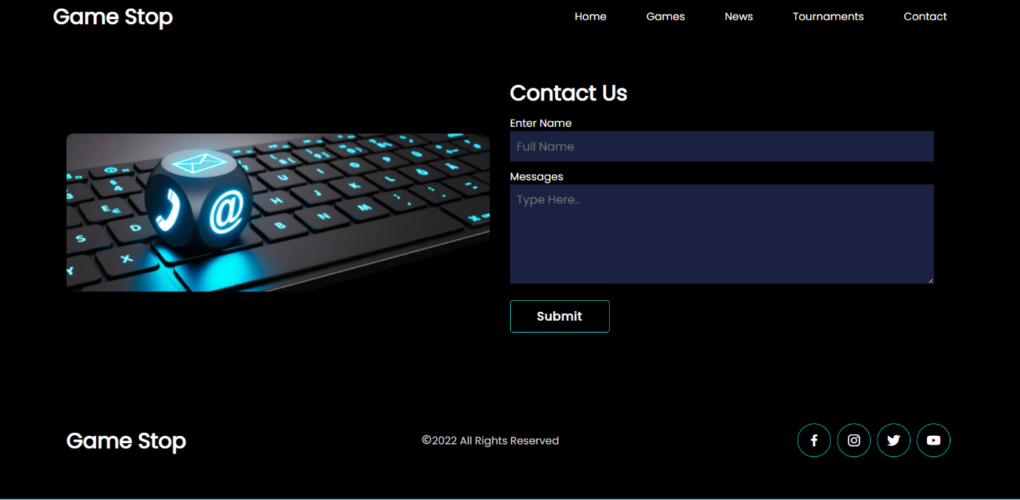

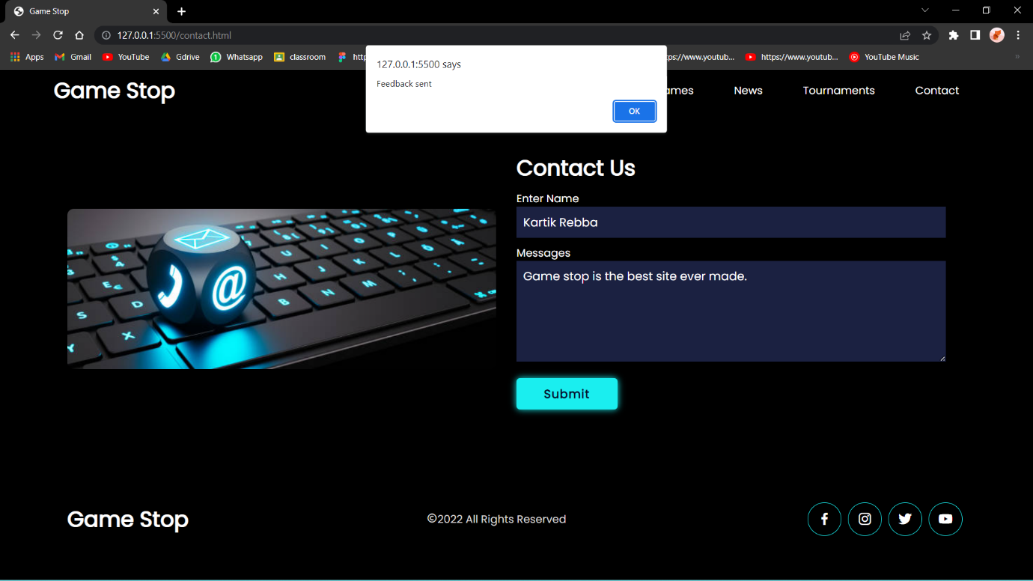

**System Implemented**

**Hardware Requirements: -**

* 1. Processor – Intel Core i3
* 2. Memory- 500mb or more
* 3. Additional Devices- USB Drive and Printer

**Software Requirements: -**

* 1. Operating System - Windows 10/ 11
* 2. Front End - HTML, CSS, JavaScript
* 3 Browser : Google Chrome.

**Future Scope**

1. GameStop would be very useful for new gamers or the people who want to be gamers by showing them the news that they might want.

2. It will also help the gamers to keep up with every upcoming update of their favourite games.

3. If this website is brought into use, then it will be very helpful for alot of people.

4. This website will help viewers to watch their favourite streamer’s competing with each other fiercely in their favourite game.

5. Our website will showcase certain games which are rated globally as per users liking, also it will contain links to play them or purchase them.

**Bibliography And References**

* <https://stackoverflow.com/>
* <https://www.w3schools.com/>
* <https://www.ubisoft.com/en-us/company/careers/locations/pune>
* <https://store.steampowered.com/>